stonehenge history

**Stonehenge**, prehistoric stone circle monument, cemetery, and archaeological site located on [Salisbury Plain](https://www.britannica.com/place/Salisbury-Plain-England), about 8 miles (13 km) north of [Salisbury](https://www.britannica.com/place/Salisbury-England), [Wiltshire](https://www.britannica.com/place/Wiltshire), [England](https://www.britannica.com/place/England). Though there is no definite evidence as to the intended purpose of Stonehenge, it was presumably a religious site and an expression of the power and wealth of the chieftains, [aristocrats](https://www.britannica.com/dictionary/aristocrats), and priests who had it built—many of whom were buried in the numerous barrows close by. It was aligned on the Sun and possibly used for observing the Sun and Moon and working out the farming calendar. Or perhaps the site was dedicated to the world of the ancestors, separated from the world of the living, or was a healing centre. Whether it was used by the [Druids](https://www.britannica.com/topic/Druid) ([Celtic](https://www.britannica.com/topic/Celtic) priests) is doubtful, but present-day Druids gather there every year to hail the midsummer sunrise. Looking toward the sunrise, the entrance in the northeast points over a big pillar, now leaning at an angle, called the Heel Stone. Looking the other way, it points to the midwinter sunset. The [summer solstice](https://www.britannica.com/science/summer-solstice-astronomy) is also celebrated there by huge crowds of visitors.

*age fotostock/SuperStock*

[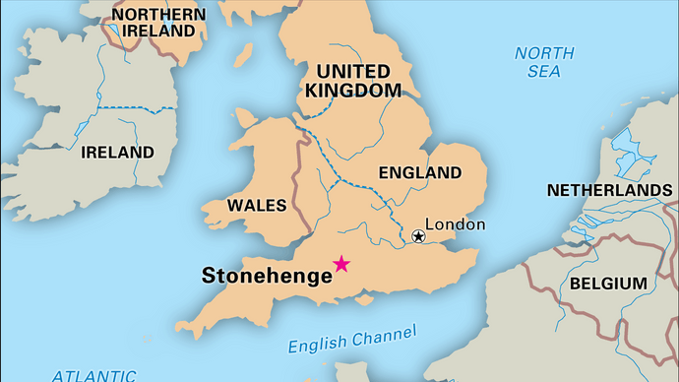](https://cdn.britannica.com/97/19697-050-420F356E/Stonehenge-Wiltshire-Eng-World-Heritage-site-1986.jpg)

[**Stonehenge**](https://cdn.britannica.com/97/19697-050-420F356E/Stonehenge-Wiltshire-Eng-World-Heritage-site-1986.jpg)

Stonehenge, Wiltshire, England, designated a World Heritage site in 1986.

*Encyclopædia Britannica, Inc.*

Stonehenge was built in six stages between 3000 and 1520 BCE, during the [transition](https://www.britannica.com/dictionary/transition) from the [Neolithic Period](https://www.britannica.com/event/Neolithic) (New Stone Age) to the [Bronze Age](https://www.britannica.com/event/Bronze-Age). As a prehistoric stone circle, it is unique because of its artificially shaped [sarsen](https://www.britannica.com/science/sarsen) stones (blocks of [Cenozoic](https://www.britannica.com/science/Cenozoic-Era) silcrete), arranged in [post-and-lintel formation](https://www.britannica.com/technology/post-and-lintel-system), and because of the remote origin of its smaller [bluestones](https://www.britannica.com/science/bluestone) ([igneous](https://www.britannica.com/science/igneous-rock) and other rocks) from 100–150 miles (160–240 km) away, in South Wales. The name of the monument probably derives from the Saxon *stan-hengen*, meaning “stone hanging” or “gallows.” Along with more than 350 nearby monuments and henges (ancient earthworks consisting of a circular bank and ditch), including the kindred temple complex at [Avebury](https://www.britannica.com/place/Avebury-archaeological-site-England), Stonehenge was designated a [UNESCO](https://www.britannica.com/topic/UNESCO) [World Heritage site](https://www.britannica.com/topic/World-Heritage-site) in 1986.